***Sentiment Analysis using VADER – Code Explanation***

***Overview***

*This script performs* ***sentiment analysis*** *on a few example sentences using the* ***VADER*** *(Valence Aware Dictionary and sentiment Reasoner) tool from the vaderSentiment module.*

*It classifies each sentence as* ***Positive****,* ***Negative****, or* ***Neutral****, and also prints out detailed sentiment scores.*

***Libraries Used***

**

* ***SentimentIntensityAnalyzer****: A pre-trained, rule-based model for sentiment analysis tuned especially for social media and short text.*

***How It Works***

***1. Creating the Analyzer***

*The analyzer is created once inside the function:*

**

***2. Analyzing Sentiment***

*For each input sentence, the method:*

**

*returns a dictionary like:*

*C:\Users\DELL\Pictures\Screenshots\Screenshot 2025-04-14 190516.png*

* *neg: Proportion of negative sentiment*
* *neu: Proportion of neutral sentiment*
* *pos: Proportion of positive sentiment*
* *compound: Overall sentiment score from -1 (most negative) to +1 (most positive)*

***Sentiment Classification Logic***

*The script classifies sentiment using the* ***compound score****:*

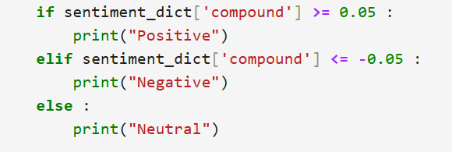

*This is based on VADER's default thresholds.*

***Example Output***

*For the sentence "I am very happy today.", the output might be:*

